**Overview**

The primary mechanic involves the player tapping on a group of at least 2 adjacent blocks of the same color, causing them to be removed. Blocks above then fall down to fill the empty space, and new blocks enter from above if necessary. I also implemented multiple icon sprites depending on group size (small, medium, large, extra large) and a non‐random “smart shuffle” feature to handle potential deadlocks.

**Tools And Packages**

**Unity 2021+**

I used Unity for the entire development process, taking advantage of its 2D workflow and built‐in physics for simpler block dropping.

**C#**

All game logic is written in C# scripts, organized by features (BoardManager, DeadlockResolver, InputHandler, etc.).

**DOTween**

This is a popular tweening engine in Unity. I used DOTween for smooth animations like blocks falling, fading in/out, and scale changes (for both feedback and shuffle animations). It helps keep the code tidy and allows for easy control over easing functions and durations.

**Run the game via MainMenu.**

**For best visual and proper positioning to prefabs use with Full HD 1920x1080 mode and set the scale to the lowest.**



**3. Key Systems and Methods**

A. Board Data and Initialization

* The **BoardData** class holds information like the number of rows, columns, and the current array of blocks.
* On startup, the **BoardManager** script spawns initial blocks (one per valid cell), assigning each a random color ID from the available color pool (1 to 6 colors).
* Each block has references to threshold values (for switching the icon sprite based on group size).

**B. Group Matching**

* I used a **Depth‐First Search (DFS)** or **Stack‐based approach** to find all adjacent blocks (up, down, left, right) of the same color:
  + When the player taps a block, I locate its index within the board.
  + I explore all neighbors of the same color.
  + If 2 or more connected blocks are found, they form a valid group to be removed.

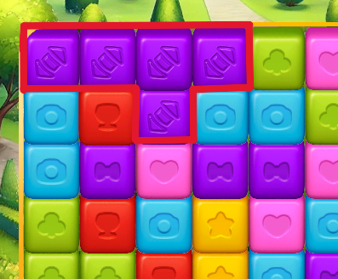 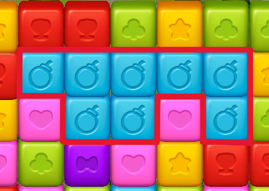

**C. Icon Switching Based on Group Size**

* Each block holds multiple sprite references:
  + Default icon
  + First threshold icon (e.g., if group size > A)
  + Second threshold icon (e.g., if group size > B)
  + Third threshold icon (e.g., if group size > C)
* Once the group size is determined, each block in that group updates its icon accordingly.

**D. Removal and Block Falling**

* When a valid group is removed, I clear those blocks and allow blocks above to fall down:
  + I reorganize the board from top to bottom within each column.
  + If new blocks are needed, they are spawned above the board and dropped into place.
* **DOTween** animates the movement, scaling, and fading of blocks.



**E. Deadlock Detection and Shuffle**

* A **Deadlock** occurs if there are no groups of 2 or more adjacent same‐colored blocks.
* My **DeadlockResolver** class checks each block and performs a quick adjacency check to see if any potential group exists.
* If no groups exist, a single **smart shuffle** routine rearranges the colors in the board (rather than randomizing multiple times). It ensures at least one match.



**4. Performance Considerations**

* Pooling

I used BlockPool (and optionally a ParticlePool) to avoid excessive Instantiate/Destroy calls. When blocks are removed, they’re returned to a pool, then reused later.

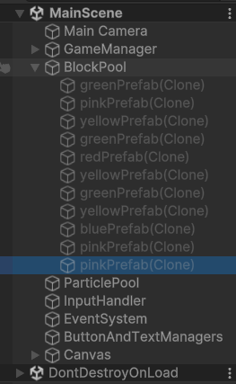

* DOTween TweensCapacity

In Awake(), I call DOTween.SetTweensCapacity(...) to reduce memory allocation overhead for tween animations.

* ScriptableObject Usage

Each level has its own unique config file which has separate settings for everything in the levels.

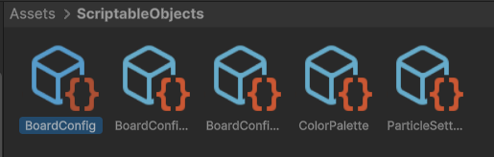

**1st Level has 8x8 classic rectangular table and a basic goal.**

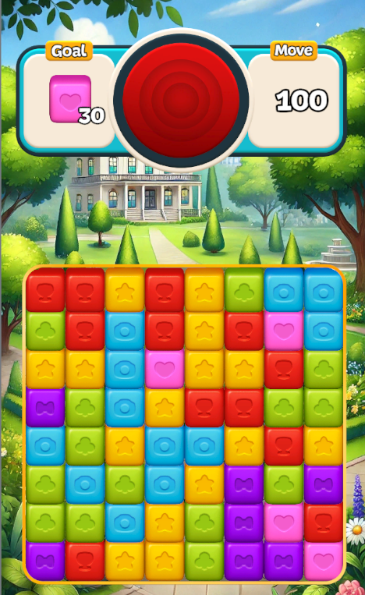

**2nd Level has plus sign shape and basic goal i did the shape with using cell mask logic.**

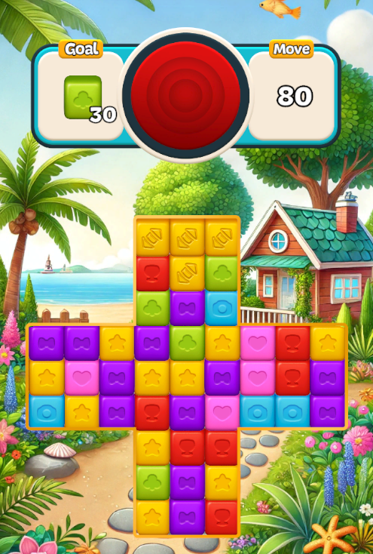

**3rd Level has crate mechanic which blasts the crates when a match happen near them.**

